**I. Pen-and-paper**

1. 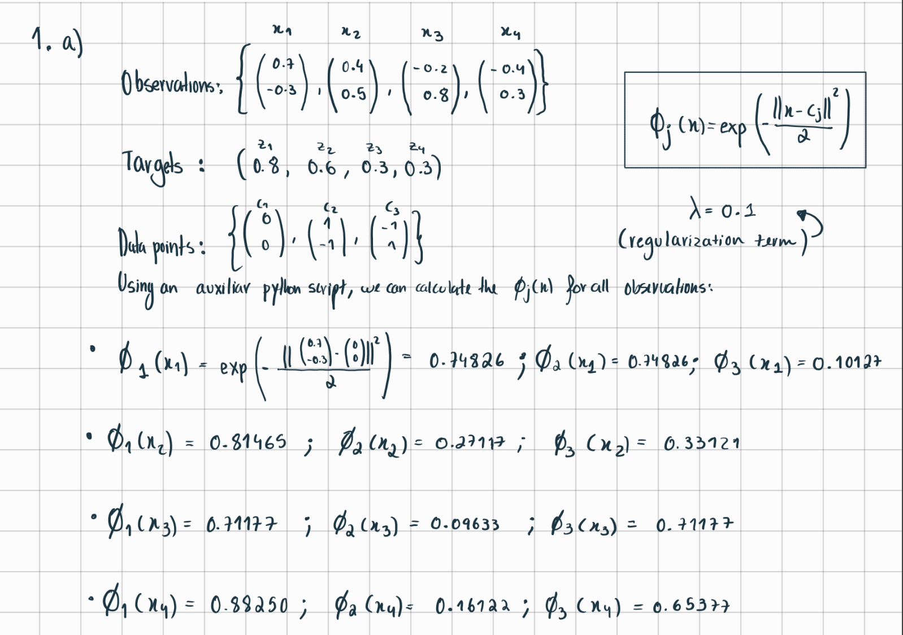A graph paper with numbers and equations

   Description automatically generatedA graph paper with numbers and equations

   Description automatically generatedA graph paper with numbers and lines

   Description automatically generatedA math equations on a grid

   Description automatically generatedA math equations on a grid

   Description automatically generated
2. A math equations on a grid

   Description automatically generatedA math equations on a grid

   Description automatically generatedA math equations on a grid

   Description automatically generated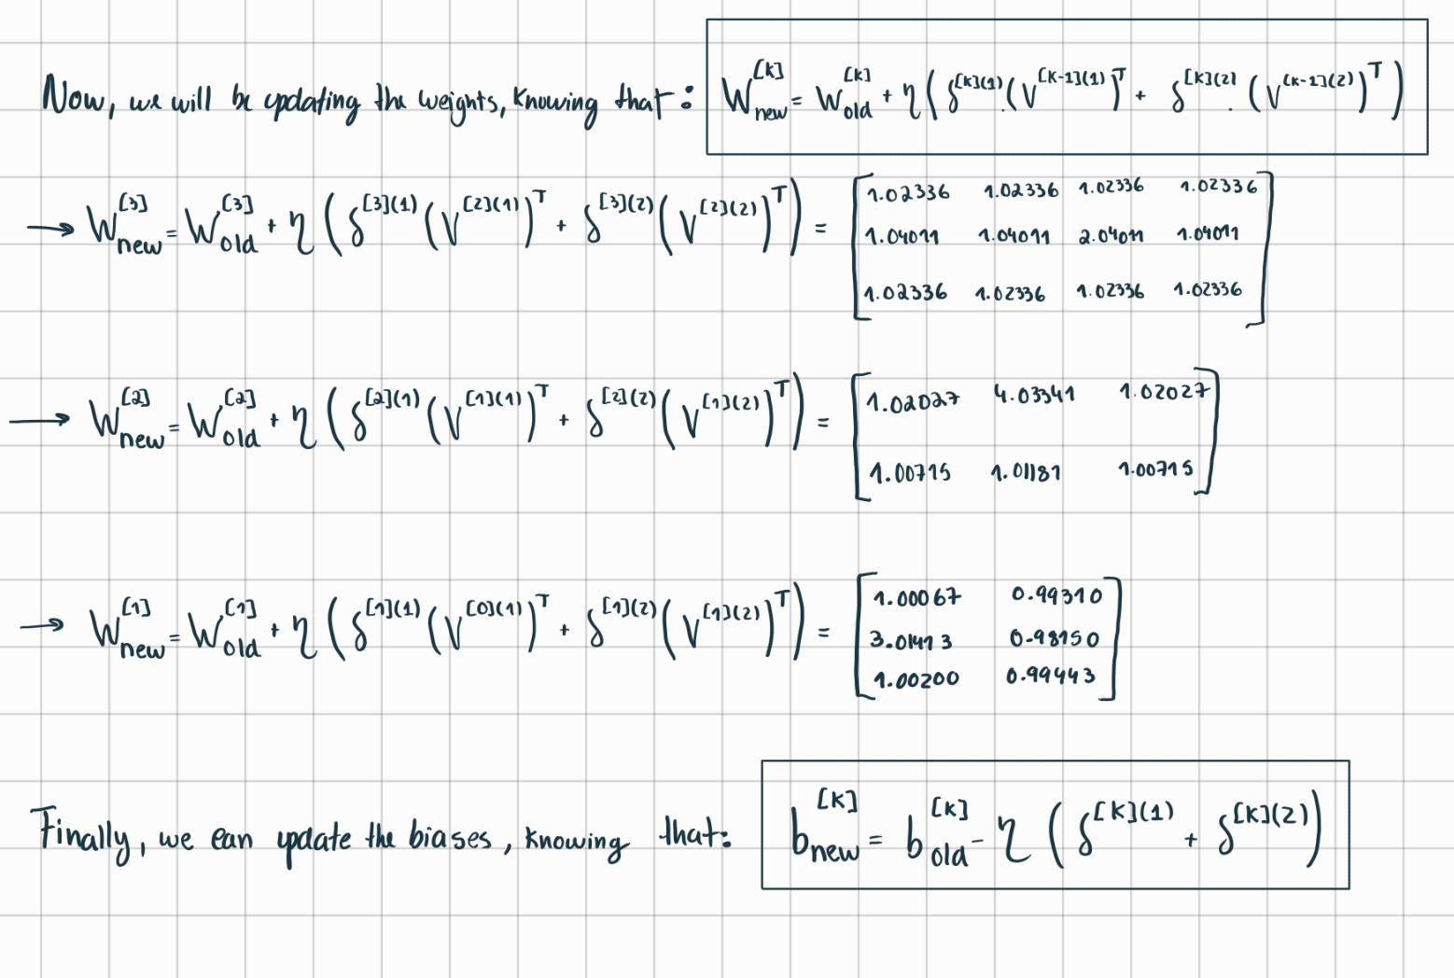A math equations on a grid

   Description automatically generated

**II. Programming and critical analysis**

1. A screenshot of a computer program

   Description automatically generatedA screenshot of a computer program

   Description automatically generatedA screenshot of a graph

   Description automatically generated
2. A screen shot of a computer program

   Description automatically generated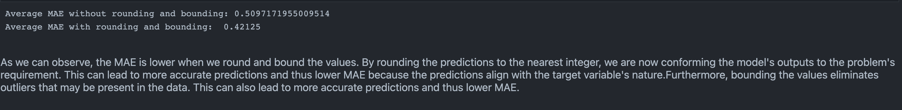
3. A computer code with text

   Description automatically generatedA screenshot of a computer program

   Description automatically generatedA black background with white text

   Description automatically generated

**END**